# 



**DESIGN AND SIMULATION OF BOW TIE ANTENNA FOR GPR APPLICATIONS**

##### A MINOR PROJECT - IV REPORT

###### ***Submitted by***

|  |  |
| --- | --- |
| **SANJAI B** | **927621BEC176** |
| **SANJAI K** | **927621BEC177** |
| **SARVESH M D** | **927621BEC188** |
| **SANGEETH V** | **927621BEC174** |

###### 

##### 

**BACHELOR OF ENGINEERING**

in

**DEPARTMENT OF ELECTRONICS AND COMMUNICATION ENGINEERING**

**M.KUMARASAMY COLLEGE OF ENGINEERING**

(Autonomous)

**KARUR – 639 113**

**MAY 2024**

**M.KUMARASAMY COLLEGE OF ENGINEERING, KARUR**

**BONAFIDE CERTIFICATE**

Certifiedthatthis **18ECP106L - Minor Project - IV** report “**DESIGN AND SIMULATION OF BOW TIE ANTENNA FOR GPR APPLICATIONS”** is the bonafide workof “**SANJAI B (927621BEC176), SANJAI K (927621BEC177), SARVESH M D (927621BEC188), SANGEETH V (927621BEC174)”** who carried out the project work under my supervision in the academic year **2023 -2024 - EVEN SEMESTER**.

**SIGNATURE SIGNATURE**

**Dr.A.KAVITHA B.E., M.E., Ph.D**., **Dr.A.KAVITHA B.E., M.E., Ph.D**.,

**HEAD OF THE DEPARTMENT, HEAD OF THE DEPARTMENT,**

Professor, Professor,

Department of Electronics and Department of Electronics and

Communication Engineering, Communication Engineering,

M.Kumarasamy College of Engineering, M.Kumarasamy College of Engineering, Thalavapalayam, Thalavapalayam,

Karur-639113. Karur-639113.

This report has been submitted for the **18ECP106L – Minor Project - IV** final review held at M. Kumarasamy College of Engineering, Karur on ____________________

**PROJECT COORDINATOR**

**INSTITUTION VISION AND MISSION**

**Vision**

To emerge as a leader among the top institutions in the field of technical education.

**Mission**

**M1:** Produce smart technocrats with empirical knowledge who can surmount the global challenges.

**M2:** Create a diverse, fully -engaged, learner -centric campus environment to provide quality education to the students.

**M3:** Maintain mutually beneficial partnerships with our alumni, industry and professional associations

**DEPARTMENT VISION, MISSION, PEO, PO AND PSO**

**Vision**

To empower the Electronics and Communication Engineering students with emerging technologies, professionalism, innovative research and social responsibility.

**Mission**

**M1:** Attain the academic excellence through innovative teaching learning process, research areas & laboratories and Consultancy projects.

**M2:** Inculcate the students in problem solving and lifelong learning ability.

**M3:** Provide entrepreneurial skills and leadership qualities.

**M4:** Render the technical knowledge and skills of faculty members.

**Program Educational Objectives**

**PEO1:** **Core Competence:** Graduates will have a successful career in academia or industry associated with Electronics and Communication Engineering

**PEO2:** **Professionalism:** Graduates will provide feasible solutions for the challenging problems through comprehensive research and innovation in the allied areas of Electronics and Communication Engineering.

**PEO3:** **Lifelong Learning:** Graduates will contribute to the social needs through lifelong learning, practicing professional ethics and leadership quality

**Program Outcomes**

**PO 1: Engineering knowledge:** Apply the knowledge of mathematics, science, engineering fundamentals, and an engineering specialization to the solution of complex engineering problems.

**PO 2: Problem analysis:** Identify, formulate, review research literature, and analyze complex engineering problems reaching substantiated conclusions using first principles of mathematics, natural sciences, and engineering sciences.

**PO 3: Design/development of solutions:** Design solutions for complex engineering problems and design system components or processes that meet the specified needs with appropriate consideration for the public health and safety, and the cultural, societal, and environmental considerations.

**PO 4: Conduct investigations of complex problems:** Use research-based knowledge and research methods including design of experiments, analysis and interpretation of data, and synthesis of the information to provide valid conclusions.

**PO 5: Modern tool usage:** Create, select, and apply appropriate techniques, resources, and modern engineering and IT tools including prediction and modeling to complex engineering activities with an understanding of the limitations.

**PO 6: The engineer and society:** Apply reasoning informed by the contextual knowledge to assess societal, health, safety, legal and cultural issues and the consequent responsibilities relevant to the professional engineering practice.

**PO 7: Environment and sustainability:** Understand the impact of the professional engineering solutions in societal and environmental contexts, and demonstrate the knowledge of, and need for sustainable development.

**PO 8: Ethics:** Apply ethical principles and commit to professional ethics and responsibilities and norms of the engineering practice.

**PO 9: Individual and team work:** Function effectively as an individual, and as a member or leader in diverse teams, and in multidisciplinary settings.

**PO 10: Communication:** Communicate effectively on complex engineering activities with the engineering community and with society at large, such as, being able to comprehend and write effective reports and design documentation, make effective presentations, and give and receive clear instructions.

**PO 11: Project management and finance:** Demonstrate knowledge and understanding of the engineering and management principles and apply these to one’s own work, as a member and leader in a team, to manage projects and in multidisciplinary environments.

**PO 12: Life-long learning:** Recognize the need for, and have the preparation and ability to engage in independent and life-long learning in the broadest context of technological change.

**Program Specific Outcomes**

**PSO1:** Applying knowledge in various areas, like Electronics, Communications, Signal processing, VLSI, Embedded systems etc., in the design and implementation of Engineering application.

**PSO2:** Able to solve complex problems in Electronics and Communication Engineering with analytical and managerial skills either independently or in team using latest hardware and software tools to fulfil the industrial expectations.

|  |  |
| --- | --- |
| **Abstract** | **Matching with POs, PSOs** |
| Bow Tie antenna, AMC Surface, GPR, fractional bandwidth (FBW). | PO1, PO2, PO3, PO4, PO5, PO6, PO7, PO8, PO9, PO10, PO11, PO12 |

**ACKNOWLEDGEMENT**

Our sincere thanks to Thiru.M.Kumarasamy, Founder and Dr.K.Ramakrishnan, Chairman of M.Kumarasamy College of Engineering for providing extraordinary infrastructure, which helped us to complete this project in time.

It is a great privilege for us to express our gratitude to Dr.B.S.Murugan., B.Tech., M.Tech., Ph.D., Principal for providing us right ambiance to carry out this project work.

We would like to thank Dr.A.Kavitha, B.E., M.E., Ph.D., Professor and Head, Department of Electronics and Communication Engineering for his unwavering moral support and constant encouragement towards the completion of this project work.

We offer our wholehearted thanks to our Project Supervisor, Dr.K.Karthikeyan, B.E., M.Tech., Ph.D., Associate Professor, Department of Electronics and Communication Engineering for his precious guidance, tremendous supervision, kind cooperation, valuable suggestions, and support rendered in making our project successful.

We would like to thank our Minor Project Co-ordinator, Dr.K.Karthikeyan, B.E., M.Tech., Ph.D., Associate Professor, Department of Electronics and Communication Engineering for his kind cooperation and culminating in the successful completion of this project work. We are glad to thank all the Faculty Members of the Department of Electronics and Communication Engineering for extending a warm helping hand and valuable suggestions throughout the project. Words are boundless to thank our Parents and Friends for their motivation to complete this project successfully.

**ABSTRACT**

In this project, we are proposed a low-profile bow tie antenna loaded by a rectangular array of Artificial Magnetic Conductor Metasurface (AMC) for ground penetrating radar (GPR) applications. The proposed antenna operates from 200MHz to 400MHz, with stable radiation characteristics. The proposed work presents several novel aspects, including the unconventional placement of the AMC structure directly at the back of the substrate without any separation to maintain the design simplicity and robustness. This utilization of AMC unit cells results in bandwidth improvement and gain enhancement. An analytical formula for the reflection coefficient has been introduced and compared to full wave simulation to investigate AMC partial reflectivity at low frequencies. The prospective antenna has a size of 6 ×6 cm and covers a vast fractional bandwidth (FBW) of 79.4%, which is significantly higher than the conventional bowtie antenna's 20% FBW. Furthermore, a back reflector is placed at 33.3 cm from the antenna to eliminate the back radiation, avoid unwanted clutters during the GPR measurements and increase the antenna gain using an AMC Surface.

.

**Keywords**: Bow Tie antenna, AMC Surface, GPR, fractional bandwidth (FBW).

**TABLE OF CONTENTS**

|  |  |  |  |  |
| --- | --- | --- | --- | --- |
| **CHAPTER No.** | **CONTENTS** | | | **PAGE No.** |
|  | **Institution Vision and Mission** | | | Iii |
|  | **Department Vision and Mission** | | | Iii |
|  | **Department PEOs, POs and PSOs** | | | Iv |
|  | **Abstract** | | | Viii |
|  | **List of Figures** | | | Xi |
|  | **List of Tables** | | | Xi |
|  | **List of Abbreviations** | | | Xii |
| **1** | **INTRODUCTION** | | | 1 |
| **2** | **OBJECTIVES** | | | 4 |
| **3** | **LITERATURE SURVEY** | | | 5 |
| **4** | **EXISTING SYSTEM`** | | | 7 |
|  | **4.1** | | A Wideband reflector-backed antenna for applications in GPR | 7 |
|  | **4.2** | | Radiation Enhancement of an Ultrawideband unidirectional folded Bow tie antenna for GPR applications | 8 |
|  | **4.3** | | Implementation of and experimentation with ground-penetrating radar for real time automatic detection of buried improvised explosive devices | 9 |
|  | **4.4** | | Compact slot antenna with low dispersion for ground penetrating radar application | 10 |
|  | **4.5** | | A 900MHz shielded bow tie antenna system for ground penetrating radar | 11 |
| **5** | **PROPOSED SYSTEM** | | | 12 |
|  | **5.1** | | AMC Meta surface Reflectivity | 13 |
|  | **5.2** | | Design Methodology | 15 |
|  | **5.3** | | Equivalent Circuit Model for Antenna Loaded by AMC | 17 |
| **6** | **TOOLS USED** | | | 19 |
| **7** | **RESULT AND DISCUSSION** | | | 20 |
|  | **7.1** | Return Loss | | 20 |
|  | **7.2** | Gain | | 21 |
|  | **7.2** | Radiation Pattern | | 22 |
| **9** | **CONCLUSION** | | | 23 |
|  | **REFERENCES** | | | 24 |

**LIST OF FIGURES**

|  |  |  |
| --- | --- | --- |
| **FIGURE No.** | **TITLE** | **PAGE No.** |
| **5.1** | Configuration of square AMC | 14 |
| **5.2** | Proposed Bow Tie antenna. | 16 |
| **5.3** | Equivalent circuit of loaded antenna | 18 |
| **6.1** | Software icon | 19 |
| **7.1** | Return loss proposed Bow Tie antenna | 20 |
| **7.2** | 3D Polar Plot for Gain (dB) | 21 |
| **7.3** | Radiation Pattern of the Proposed antenna | 22 |

**LIST OF TABLES**

|  |  |  |
| --- | --- | --- |
| **Table No.** | **Table Name** | **PAGE No.** |
| **1** | Antenna and AMC dimensions | 16 |
| **2** | Equivalent circuit lumped elements values | 18 |

**LIST OF ABBREVIATIONS**

|  |  |  |
| --- | --- | --- |
| **ACRONYM** |  | **ABBREVIATION** |
| GPR | - | MULTIPLE INPUT, MULTIPLE OUTPUT |
| TSA | - | TAPERED SLOT ANTENNAS |
| HFSS | - | HIGH FREQUENCY STRUCTURE SIMULATOR |
| AMC | - | ARTIFICIAL MAGNETIC CONDUCTOR |
| UWB | - | ULTRA-WIDEBAND |
| IEDs | - | IMPROVISED EXPLOSIVE DEVICES |
| RLC | - | RESISTOR INDUCTOR CAPACITOR |
| RF | - | RADIO FREQUENCY |

CHAPTER 1  
 INTRODUCTION

Ground-penetrating radar (GPR) is a well-known non-destructive geophysical technique. It can be used to identify natural geologic materials. Currently, GPR is employed to detect other media such as wood, concrete, and asphalt. GPR can be also used for road quality assessment, buried objects detection, and civil engineering [1], [2]. GPR systems can be classified into two categories: a continuous wave that works in the frequency domain, and impulse wave, which works in the time domain. Impulse-based GPR systems are less complex and cost-effective [2]. Antenna stage is one of the most critical parts of the GPR system. Basically, antenna performance characteristics required for the GPR applications, i.e., linear polarization, ease of design and fabrication, better symmetry in radiation pattern. Till now, many antenna types have been reported for GPR applications. Two main types of antennas have the greatest interest in the GPR research field [3]. The first category is the air-coupled antennas which are normally 40-50 cm above the ground surface, such as horn antennas and tapered slot antennas (TSA) [4], [5]. This category suffers from the bulky size as well as the strong mutual coupling between the transmitter and receiver. The second category is the ground-coupled antennas of planar structure, such as loaded dipole [6], spiral [7], microstrip monopole [8], bowtie antenna and, its variants [9]. The ground-coupled antennas are appropriate for working close to the ground surface; 5-10 cm above the ground. Bowtie antenna is the most popular structure for commercial GPR devices due to its excellent radiation performance [10]–[12]. The influence of the geometrical configuration and input impedance of bowtie antennas on the reflected signal strength from a near-surface object is investigated [10]. Although the bow tie antennas successfully applied for the GPR systems. However, low gain, narrow bandwidth especially at low frequencies, and high dispersion of frequency spectrum cause several limitations.

Furthermore, several techniques have been reported to improve the conventional bow tie antennas performance. Ref. [13] review some of these modifications such as the structural modification technique, which is effective solely in the high frequency range but can’t be applied in lower frequencies. Resistive loading is used for reducing the lower cut-off frequency and also reducing the antenna ringing, i.e., multiple reflections between the feed point and the open end of the bow-tie antenna due to the abrupt impedance change in the impedance level at either side of the antenna [14]. However, resistive loading is degrading the antenna radiation efficiency significantly. Reduction in radiation efficiency can be significantly minimized by using capacitive loading with resistive loading. Array configuration was proposed to improve the radiation efficiency and front to back ration (F/B) [15], also it can be enhanced using a cavity [16], [17]. Recently, metamaterials have been used for the same purpose [18]. However, the radiation properties improve at the cost of size and complexity of the bow tie antennas. A paddle shaped microstrip antenna was proposed as a modified version of the Bow tie antenna by cutting a rectangular patch at one of its diametrical edges fed by the coplanar waveguide technique. The antenna is loaded by stubs, shorting pins, and a split-ring resonator (SRR) metamaterial structure to increase the antenna gain and enhance the bandwidth (BW) towards both the lower and higher end of the working BW [19]. A grooved elliptical patch with a corrugated semi-elliptical ground plane was developed to improve the antenna bandwidth [20]. Bow tie cage antenna consists of two thick diverging cages composed of 10 cylindrical metallic rods was developed to improve the antenna bandwidth [21].

Although all the previous literature has been contributed to bandwidth and gain improvement, all work suffers from either complexity or the low frequency operating bandwidth. A modified structure of bow tie antenna is introduced for low frequency GPR applications. The prospective antenna is operating at the bandwidth ranging from 1.168GHz to 1.357GHz. This work is innovative due to the AMC matrix metasurface's design being placed directly on the backside of the antenna, without any separation as seen in traditional designs, which eliminates the surface wave and enhances both the antenna gain and directivity. A metallic reflector is further added behind the AMC metasurface to improve the antenna gain at the lower frequencies. A transmission line model is introduced to study the reflectivity of the metasurface structure. The simulation model is analyzed using High Frequency Structure Simulator (HFSS). To the best of our knowledge, no work has been reported for the low frequency GPR antenna, with AMC attached directly to the antenna to improve the gain, the bandwidth and maintain the antenna robustness.

**CHAPTER 2**

**OBJECTIVES**

* The main objective of this project is to understand the working and the design of the antenna.
* To design the antenna according to designed specifications.
* To be acquainted with some of the characteristics of parasitic antenna element modelling and operations.
* To know the radiation pattern of antenna.
* To know the return loss of antenna.
* To know gain of antenna.

**CHAPTER 3**

**LITERATURE SURVEY**

The initial step in beginning the project is reading the research paper that has already been completed by another researcher. The selected and examined papers are those that are linked to this title. This literature review provides a clearer grasp of how to carry out the Research into related technologies has increased steadily as GPR Applications standards and technology have developed. The ultimate goal is to achieve higher gain, cheaper cost, and higher bandwidth. Achieving a greater bandwidth enquires the use of GPR technology.

TSA is renowned for its wideband attributes, rendering it apt for UWB applications. In this study, a compact TSA design meticulously optimized for UWB radar systems. The design endeavors to enhance performance while upholding a diminutive physical footprint. The methodology section expounds on the antenna's geometry, dimensions, and material selection. Moreover, the author furnishes measurement outcomes to authenticate the efficacy of the proposed antenna design. Domain of UWB microwave imaging radar by furnishing a compact TSA design imbued with enhanced performance traits. Its findings are particularly invaluable to engineers and researchers entrenched in radar systems, particularly those delving into UWB applications [5].

The advancement of UWB antenna technology by presenting a miniaturized compound spiral antenna with wideband characteristics. Engineers and researchers in the field of microwave technology and computational electromagnetics, particularly those interested in UWB applications [7].

The magnetic-loop based monopole antenna is specifically tailored for GPR applications, aiming to improve detection accuracy and depth penetration. The authors detail the design and implementation of the antenna, highlighting its unique features and advantages. By utilizing a magnetic-loop design, the antenna achieves enhanced performance in terms of sensitivity and resolution, crucial for GPR applications. The research also provides experimental results, demonstrating the effectiveness of the proposed antenna for GPR systems [8].

The focus of the study is on Bi-static GPR antennas, which involve separate transmitter and receiver antennas positioned at a distance from each other. The authors explore the design and operational parameters of these antennas to optimize their performance for near-surface object detection. This includes examining factors such as antenna geometry, frequency range, and signal processing techniques.[10]

**CHAPTER 4**

**EXISTING SYSTEM**

**4.1 A Wideband reflector-backed antenna for applications in GPR**

Raza et al. present a novel wideband reflector-backed antenna designed specifically for applications in Ground Penetrating Radar (GPR). This research addresses the need for improved antenna designs tailored to enhance the performance of GPR systems across a wide frequency range.

The focus of this study lies in the development of a reflector-backed antenna capable of operating efficiently over a broad frequency spectrum, essential for various GPR applications including subsurface imaging and non-destructive testing. The authors meticulously explore the design parameters such as antenna geometry, feed mechanism, and materials to achieve the desired wideband characteristics.

Through comprehensive simulations and experimental validations, the research team evaluates the performance of the proposed reflector-backed antenna in terms of bandwidth, radiation pattern, and gain. They provide insights into the antenna's ability to accurately detect and characterize subsurface targets across different soil conditions and depths.

The findings of this study significantly contribute to the advancement of GPR technology by introducing a wideband antenna solution optimized for enhanced performance in subsurface sensing applications. Researchers and engineers working in the fields of remote sensing, geophysics, civil engineering, and archaeology can benefit from the insights provided by this research to improve the capabilities and effectiveness of GPR systems.

**4.2 Radiation Enhancement of an Ultrawideband unidirectional folded Bow tie antenna for GPR applications**

Yang et al. present research focused on enhancing the radiation performance of an ultrawideband unidirectional folded bow tie antenna for Ground Penetrating Radar (GPR) applications. The study addresses the need for improved antenna designs capable of achieving enhanced radiation characteristics across a wide frequency spectrum, crucial for accurate subsurface imaging and detection.

The primary objective of the research is to enhance the radiation performance of a folded bow tie antenna to meet the requirements of GPR applications. The authors explore various design parameters such as antenna geometry, dimensions, and folding techniques to achieve improved radiation characteristics, including enhanced bandwidth and directivity.

Through comprehensive simulations and experimental validations, the research team evaluates the performance of the proposed ultrawideband unidirectional folded bowtie antenna. Parameters such as radiation pattern, gain, and bandwidth are analyzed to ensure accurate and reliable detection of subsurface targets across different soil conditions and depths.

This research significantly contributes to the advancement of GPR technology by introducing an antenna solution optimized for enhanced radiation performance in subsurface sensing applications. Engineers and researchers in fields such as remote sensing, geophysics, civil engineering, and archaeology can benefit from the insights provided by this study to improve the capabilities and effectiveness of GPR systems.

**4.3 Implementation of and experimentation with ground-penetrating radar for real time automatic detection of buried improvised explosive devices**

Srimuk et al. present the implementation and experimentation of Ground-Penetrating Radar (GPR) for real-time automatic detection of buried Improvised Explosive Devices (IEDs). This research addresses the urgent need for effective and efficient detection techniques to mitigate the threats posed by buried IEDs in various operational environments.

The primary objective of the study is to develop and deploy a GPR system capable of real-time automatic detection of buried IEDs. The authors detail the implementation process, including the selection of GPR hardware components, system integration, and software development for signal processing and analysis.

Through extensive field experimentation and testing, the research team evaluates the performance of the GPR system in detecting buried IEDs in real-time scenarios. They assess parameters such as detection accuracy, false alarm rate, and response time to demonstrate the effectiveness and reliability of the proposed detection method.

This research significantly contributes to the advancement of security and defense technologies by introducing a real-time automatic detection system for buried IEDs using GPR. Military personnel, law enforcement agencies, and security professionals can benefit from the insights provided by this study to enhance their capabilities in detecting and neutralizing threats posed by buried explosive devices in various operational environments.

**4.4 Compact slot antenna with low dispersion for ground penetrating radar application**

Li et al. introduce a compact slot antenna with low dispersion specifically designed for Ground Penetrating Radar (GPR) applications. This research addresses the need for antenna designs capable of providing accurate and high-resolution subsurface imaging while minimizing signal dispersion.

The primary focus of the study is on developing a compact slot antenna optimized for GPR applications. The authors explore design parameters such as antenna geometry, dimensions, and materials to achieve low dispersion characteristics, crucial for enhancing the resolution and accuracy of GPR systems.

Through extensive simulations and experimental validations, the research team evaluates the performance of the proposed compact slot antenna. Parameters such as dispersion, bandwidth, and radiation pattern are analyzed to ensure accurate and reliable detection of subsurface targets across different soil conditions and depths.

This research significantly contributes to the advancement of GPR technology by introducing a compact slot antenna solution optimized for low dispersion and high-resolution subsurface imaging. Engineers and researchers in fields such as remote sensing, geophysics, civil engineering, and archaeology can benefit from the insights provided by this study to improve the capabilities and effectiveness of GPR systems.

**4.5 A 900MHz shielded bow tie antenna system for ground penetrating radar**

Chen and Liu et al a 900MHz shielded bow tie antenna system designed for ground penetrating radar (GPR) applications. This research aims to improve the performance of GPR systems for subsurface imaging and detection by enhancing the antenna system's characteristics.

The primary focus of the study is on developing a shielded bow tie antenna system optimized for GPR applications operating at 900MHz. The authors explore various design parameters such as antenna geometry, dimensions, and shielding techniques to achieve improved signal penetration, resolution, and accuracy.

Through comprehensive simulations and experimental validations, the research team evaluates the performance of the proposed shielded bow tie antenna system. Parameters such as signal penetration depth, resolution, and interference rejection are analyzed to ensure accurate and reliable detection of subsurface targets in various soil conditions.

This research significantly contributes to the advancement of GPR technology by introducing a shielded bow tie antenna system optimized for enhanced performance in subsurface imaging and detection. Engineers and researchers in fields such as remote sensing, geophysics, civil engineering, and archaeology can benefit from the insights provided by this study to improve the capabilities and effectiveness of GPR systems.

**CHAPTER 5**

**PROPOSED SYSTEM**

The proposed bow tie antenna design incorporates several innovative features aimed at addressing the challenges faced in traditional GPR antenna configurations. Through meticulous design optimization and electromagnetic simulations, the authors have refined the geometry, dimensions, and materials of the antenna to achieve superior performance characteristics.

One key aspect of the proposed design is its enhanced sensitivity to weak signals and its ability to accurately detect and resolve subsurface targets with varying properties. This is achieved through careful tuning of the antenna's impedance matching and radiation pattern characteristics, resulting in improved signal-to-noise ratio and signal penetration depth.

Furthermore, the researchers have implemented advanced manufacturing techniques to ensure the reproducibility and reliability of the proposed antenna design. This includes utilizing state-of-the-art materials and fabrication processes to minimize losses and maximize antenna efficiency.

The performance of the proposed bow tie antenna is validated through comprehensive experimental testing in real-world GPR scenarios, demonstrating its efficacy in various soil conditions and depths. The experimental results showcase the superior performance of the antenna compared to existing designs, highlighting its potential for use in advanced GPR applications such as archaeological surveys, infrastructure assessment, and environmental monitoring.

**5.1 AMC Meta surface Reflectivity**

In this section, a square periodic patch is chosen because it has a large in-phase band compared to other AMC structures which have a compact size at the expense of bandwidth [22]. Fig.5.1 (a) shows the configuration of the suggested square AMC unit cells including the dimensions parameters. Fig.5.1(b) shows the HFSS simulation setup for AMC. The AMC rectangular unit cell is excited through horizontal plane wave with electric field direction perpendicular to the PEC walls.

To study the reflectivity of the rectangular periodic AMC unit cells at different frequencies, equivalent circuit model is employed as shown in Fig.5.1(c) Consequently, the reflection coefficient can be given by

$Γ=\frac{Z_{in}-η_{eff}}{Z_{in}+η_{eff}}$ (1)

Where $η_{eff}$ is the effective wave impedance inside dielectric material

$Z_{in}$ the input impedance referring to boundary surface at dielectric slab and air.

$Z_{in}=η_{eff}\frac{Z_{load}+jη_{eff}tan⁡(k_{eff}h)}{η_{eff}+jZ_{load}tan⁡(k_{eff}h)}$ (2)

$k_{eff}$ is the wave number in the dielectric material

$Z_{load}$ is parallel connection for grid impedance and the air wave impedance which is represented by:

$Z_{load}=\frac{Z_{g}η_{o}}{Z_{g}+η_{o}}$ (3)

$Z_{g}$ is the grid impedance which is related to the tangential electric field in the meta surface plane and the induced surface current density on it.

$Z_{g}^{TM,TE}=$-j $\frac{η_{eff}}{2α}$ (4)

**α** is grid parameter [23] and it has the following form:

$α$ = $\frac{2fa\sqrt{ε_{eff}}}{c}$ ln (csc ($\frac{πs}{2a}$)) (5)

Based on the abovementioned analytical formulations, the reflection at air-dielectric boundary for a normal incident plane wave is calculated using MATLAB software. For verification, a full wave simulator HFSS is utilized for the same purpose

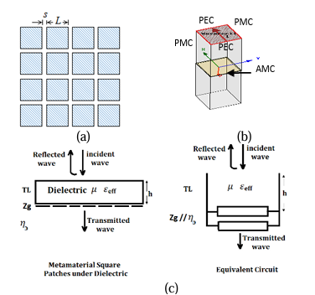

**Fig.5.1 (a) Configuration of square AMC (b) HFSS Simulation setup for AMC (c) The transmission line model for square patch grid on one side of dielectric slab.**

**5.2 Design Methodology**

In this section, the conventional bowtie antenna is presented as an initial design to our proposed modified structure and the operating center frequency is selected at 1.25GHz. Bow tie shape is a conventional design for a GPR antenna, cutting the edges of the bowtie help to reduce the antenna's overall size while also affecting its characteristic impedance. Chen et al. [24] discuss 3 different shapes for edge cutting and recommend the shape at which the length of straight part of one arm equal 0.25 of the total antenna length. The length of the bow tie L is directly related to half of the lower frequency's wavelength, while the flare angle affects the bandwidth, a larger flare angle leads to a wider bandwidth. The optimal range for flare angle is typically between 60 and 90 degrees to achieve both a wideband performance and a compact design. The bow tie length is initially determined by formula:

$L=\frac{λ}{2\sqrt{ε_{reff}}}$ (6)

Where, λ is wavelength at lower operating frequency. however, simulation is used to refine the lengths to achieve accurate resonance at 0.25GHz.

The antenna is mounted on FR4 substrate with relative permittivity 4.4 and a thickness 1.6 mm. A narrow bandwidth of about 40MHz and a 2.13dB gain are attained.

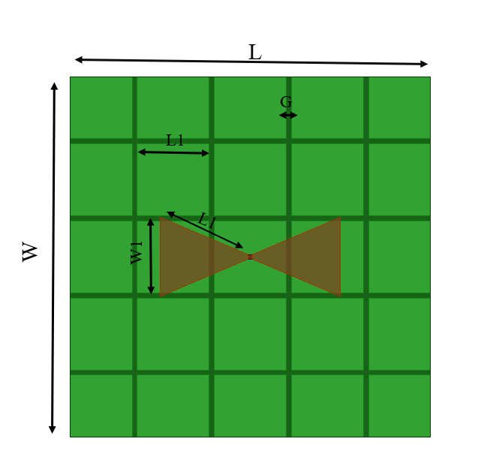

**Fig.5.2 Proposed Bow-Tie antenna.**

To improve the antenna bandwidth, a 5×5 square AMC metasurface unit are arranged on the antenna backside with 0.16cm periodic gaps. Placing the planar AMC metasurface close to antenna structure as shown in Fig.5.2 influences the antenna surface current distribution thus antenna characteristic; gain, and impedance matching are affected.

**Table 1: Antenna and AMC dimensions**

|  |  |
| --- | --- |
| Parameter | Value [cm] |
| L | 12 |
| W | 12 |
| W1 | 2.64 |
| L1 | 2.93 |
| L2 | 2.4 |
| G | 0.16 |

To enhance the gain in the low frequencies where meta-surface is partially reflective, a full metallic reflector is positioned back to the AMC plan. The distance between the antenna and the metallic reflector is optimized to introduce a constructive interference for reflected waves and the radiated one from Bow tie antenna.

* 1. **Equivalent Circuit Model for Antenna Loaded by AMC**

In this section, we establish a lumped model as depicted in Fig.5.3 by utilizing the resonant frequency of the bowtie antenna and the AMC structure. This model comprises a set of RLC resonant circuits that represent the radiating element, and a capacitor and inductor parallel to the gap capacitor to represent the periodic structure of the AMC. The complete equivalent circuit is obtained by linking the RLC bowtie antenna model to the AMC model. To analyze the performance of the bowtie antenna augmented by AMC, we used ADS circuit simulator software to simulate the equivalent circuit. Notably, the bandwidth of the antenna is heavily influenced by the AMC. The optimum values of RLC circuit are listed in table 2.

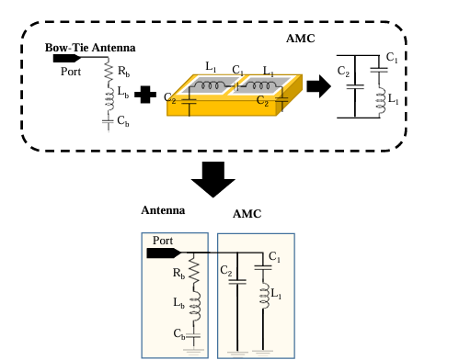

**Fig.5.3. Equivalent circuit of loaded antenna.**

**Table 2: Equivalent circuit lumped elements values**

|  |  |  |
| --- | --- | --- |
| $R_{b}$**($Ω$)** | $L_{b}$**(nH)** | $$C_{b}(pF)$$ |
| 38.062 | 22.0078 | 21.0079 |
| $$C_{1}(pF)$$ | $$C_{2}(pF)$$ | $L_{1}$**(nH)** |
| 32.0068 | 11.0089 | 62.0038 |

**CHAPTER 6**

**TOOLS USED**

**Software requirement:**

**HFSS Software**

A 3D Electromagnetic (EM) simulation program called Ansys HFSS is used to develop and simulate high-frequency electronic products such printed circuit boards, antenna arrays, RF or microwave components, high-speed interconnects, filters, and connectors.



**Fig 6.1. Software Icon**

Ansys HFSS is largely used by engineers for the design and simulation of high-speed, high-frequency electronics used in printed circuit boards, radar systems, satellites, ADAS, chips, digital devices, and other RF and digital devices. The electromagnetic behavior of things like cars has also been simulated using the solver. System and circuit designers can simulate electromagnetic problems such losses from attenuation, coupling, radiation, and reflection by using ANSYS HFSS.

**CHAPTER 7**

**RESULT AND DISCUSSION**

To validate the simulation results, the proposed bow tie antenna over the AMC structure is practically measured. Both measured and simulated results of reflection coefficient are depicted in Fig 7.1, which demonstrate that, on the basis of the low profile, the antenna operates at 1.168GHz to 1.357GHz, with a wide relative impedance bandwidth of 42.04%, while the simulated relative impedance bandwidth is 35.6%, covering from 1.68GHz to 1.37GHz. The discrepancies are caused by the effect of the SMA connector and the fabrication and measurement errors.

**7.1 RETURN LOSS**

S11 represents how much power is reflected from the antenna. It is also known as the reflection coefficient. it is the reflection of signal power caused by a gadget being inserted into a transmission line. It is stated as a decibel (dB) ratio in relation to the power of the transmitted signal. The antenna should be able to radiate effectively if the return loss is limited to less than -10dB.

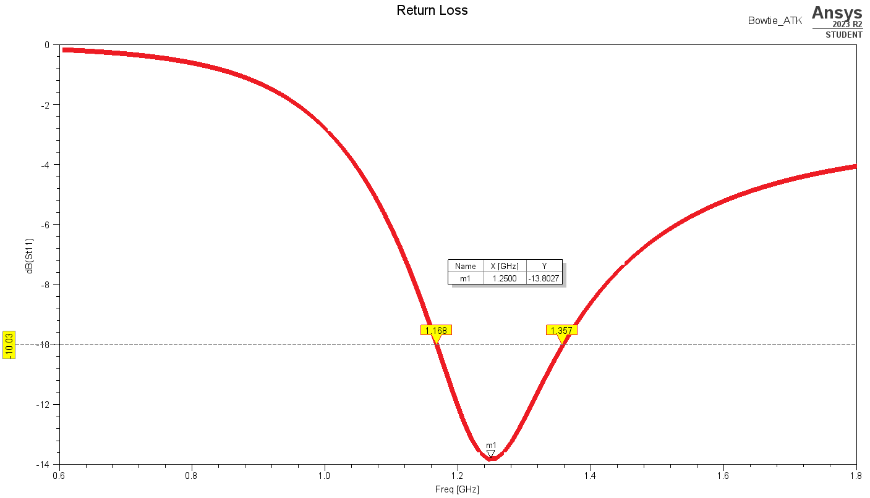

**Fig 7.1. Return loss proposed Bow-Tie antenna**

**7.2 GAIN**

It is the ratio of the maximum radiation intensity at the peak of the beam to the radiation intensity in the same direction produced by an isotropic radiator having same input power is known as the gain of the antenna.

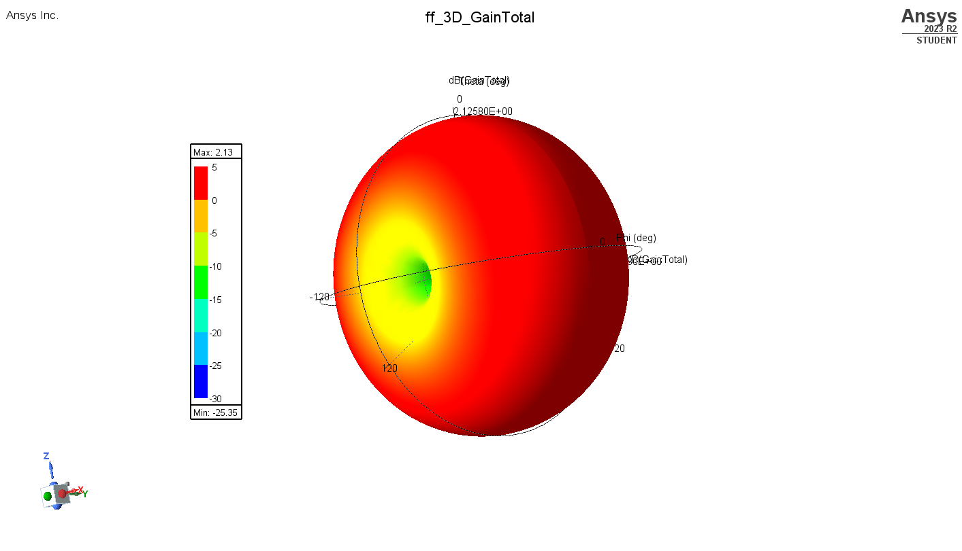

**Fig.7.1. 3D Polar Plot for Gain (dB)**

**7.3 RADIATION PATTERN**

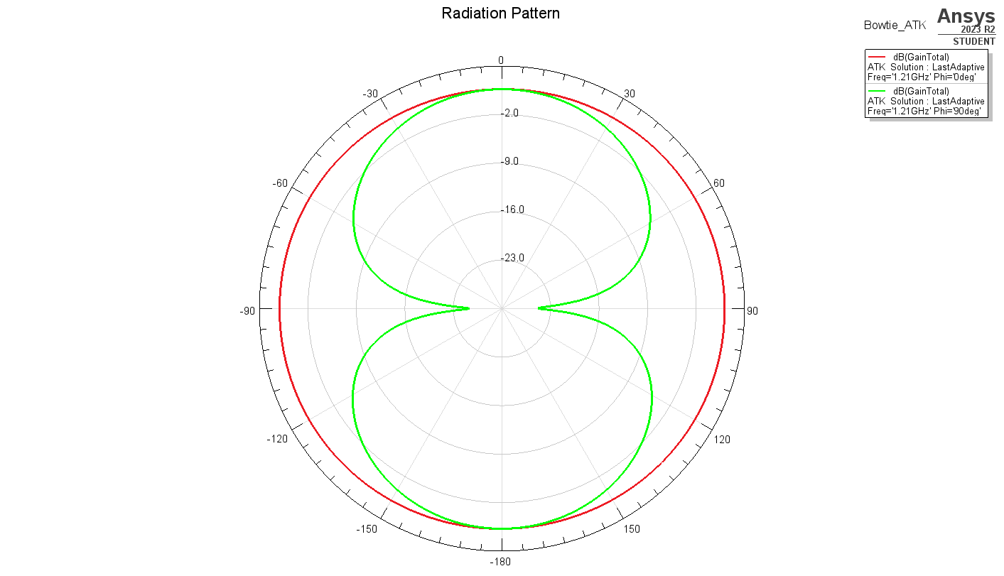The radiation pattern is a three-dimensional graphical representation of the radiation of the antenna as the function of direction. It is actually the plot of the power radiated from an antenna per units solid angle. Isotropic antennas do not exist in reality but are generally used as a reference to compare the performance of other antennas. The radiation pattern provides all the required information on antenna beam-width, side lobes and resolution of the antenna.

**Fig.7.3. Radiation Pattern of the Proposed antenna**

**CHAPTER 8**

**CONCLUSION**

An AMC-based broadband bowtie antenna is proposed for GPR application. Loaded with two parallel open stubs in the upper layer, the proposed bowtie antenna has the merit of broad band. An AMC surface composed of 5x5 unit cells is designed and located under the bowtie antenna with a distance of only one-tenth the free space wavelength at 3.0 GHz for gain enhancement and low profile. Experimental results show that, with maintaining the low profile, the composite antenna achieves a wide bandwidth (return loss -10 dB) of 35.6%, operating from 1.163 to 1.357 GHz. A flat gain from 2.13dBi are found over the whole band. Measured results demonstrate that the antenna achieves a wide relative frequency bandwidth of 42.04%, operating from 1.163.48 to 1.357 GHz. The measured maximum gain is up to 2.13dBi. Moreover, low front-to-back ratios and cross-polarization level is obtained simultaneously. Good agreement lies between the measured and simulated results.

**REFERENCES**

[1] P. Taylor, L. Pajewski, and A. Benedetto, “Preface.” Nondestruct. Testing and Eval., Vol.27, No. 3 pp. 187 88, Sept. 2012. doi: 10.1080 /10589759. 2012. 710389.

[2] Huston and D. Busuioc, “Radar technology: radio frequency, interferometric, millimeter wave and terahertz sensors for assessing and monitoring civil infrastructures,” in Sensor Technol. for Civil Infrastructures, Vol.55, pp. 201–237, May 2014. doi: 10.1533/9780857099136.201.

[3] N. Diamanti and A. P. Annan, “Air-launched and ground-coupled GPR data,” in 2017 Eur. Con. on Antennas and Propa.(EUCAP), Paris, France, pp. 1694–98, Mar. EuCAP.2017.7928409

[4] Ahmed, Y. Zhang, D. Burns, D. Huston, and T. Xia, “Design of UWB antenna for air-coupled impulse ground-penetrating radar,” IEEE Geosci. and Remote Sens. Lett., Vol.13, No. 1, pp. 92–96, Jan. 2016. doi:10.1109/LGRS.2015.2498404.

[5] B. Wu, “Design and measurement of compact tapered slot antenna for UWB microwave imaging radar,” IEEE Int. Conf. on Electron. Meas. & Instrum., Beijing, China: IEEE, pp. 2-226-2–22. & Instrum., Beijing, China: IEEE, pp. 2-226-2–229, Aug. 2009. Doi:10.1109/ICEMI.2009.5274613.

[6] Lee, “Investigation of the pulse radiating performance of resistively loaded dipole antennas by manipulation of the loading parameter,” AEU – Int. J. of Electron. and Commun., Vol. 98, pp. 248–58, Jan. 2019, doi: 10.1016/j.aeue.2018.11.003.

[7] N. Liu, P. Yang, and W. Wang, “Design of a miniaturized ultra-wideband compound spiral antenna,” IEEE Int. Conf. on Microw. Technol. & Comput. Electromagn., Qingdao, China, pp.255–58, Aug. 2013. doi: 0.1109/ICMTCE.2013.6812453.

[8] Raza, W. Lin, Y. Liu, A. B. Sharif, Y. Chen, and C. Ma, “A magnetic‐loop based monopole antenna for GPR applications,” Microw. Opt. Technol. Lett., Vol. 61, No. 4, pp. 1052–1057, Apr. 2019, doi: 10.1002/mop.31690.

[9] Z Mr. Rajesh N. I. Medhat, A. S. A. El-hameed, and M. Sato, “Application of cross -Bowtie antenna to detection of buried pipes by GPR” IEICE Tech. Rep., Vol. 119, No.121, pp.61-66, July 2019.

[10] X. Gao, F. J. W. Podd, W. Van Verre, D. J. Daniels, and A. J. Peyton, “Investigating the performance of Bi-static GPR antennas for near-surface object detection,” Sensors, Vol. 19, No. 1, p. 170, Jan. 2019, doi: 10.3390/s19010170.

[11] J. Ali, N. Abdullah, M. Yusof, E. Mohd, and S. Mohd, 7, “Ultra-Wideband antenna design for GPR applications: a review,” Int. J. of Adv. Comput. Sci. and App., Vol. 8, No. pp. 392–400, doi: 10.14569/ijacsa.2017.080753.

[12] Warren and A. Giannopoulos, “Creating finite difference time-domain models of commercial ground- penetrating radar antennas using Taguchi’s optimization method,” Geophysics, Vol. 76, No. 2, pp. G37–G47, Mar. 2011, doi: 10.1190/1.3548506.

[13] R. Nayak, S. Maiti, R. Nayak, and S. Maiti, “A review of Bow-tie antennas for GPR applications,” IETE Technical Review, Vol. 36, No.4, pp. 382–397, Jul. 2019, doi: 10.1080/02564602.2018.1492357.

[14] Raza, W. Lin, M. K. Ishfaq, M. Inam, F. Masud, and M. H. Dahri, “A Wideband reflector-backed antenna for applications in GPR,” Int. J. Of Antennas and Propag., ,Nov. 2021.

[15] Y. Ren and C. Lai, “Wideband antennas for modern radar systems,” Radar Technology. InTech, Jan. 2010. doi: 10.5772/7187.

[16] S. Liu, M. Li, H. Li, L. Yang, and X. Shi, “Cavity backed bow-tie antenna with dielectric loading for ground- penetrating radar application,” IET Microw. Antenna Propag., Vol.14, No.2, pp. 153–157, Feb. 2020, doi: 10.1049/ iet-map.2019.0309.

[17] Elsherbini, J. Wu, and K. Sarabandi, “Dual polarized wideband directional coupled sectorial loop antennas for radar and mobile base-station applications,” IEEE Trans. Antennas Propag., Vol. 63, No. 4, pp. 1505 1513, Apr. 2015, doi: 10.1109/TAP.2015.2392773.

[18] K. K. Ajith and A. Bhattacharya, “printed compact lens antenna for UHF band applications,” Prog. In Electromagn. Research C, Vol. 62, pp. 11–22, Jan. 2016, doi: 10.2528/PIERC15112702.

[19] T. Saeidi, A. R. H. Alhawari, A. H. M. Almawgani, T. Alsuwian, M. A. Imran, and Q. Abbasi, “High gain compact UWB antenna for ground penetrating radar detection and soil inspection,” Sensors, Vol. 22, no 14, p. 5183, Jul. 2022. doi: 10.3390/s22145183.

[20] M. Guerrouj, A. Chaabane, and A. Boualleg, “Super UWB grooved and corrugated antenna for GPR application super UWB grooved and corrugated antenna for GPR application,” Period. Polytech. Elec. Eng. Comp. Sci., Vol. 66, No. 1, pp. 31–37, Jan. 2022, doi: 10.3311/PPee.17221

[21] G. Kumar, M. B. Mahajan, P. Mevada, and S. Chakrabarty, “Ultrawide band cage dipole antenna for ultra-high frequency band ground penetrating radar system,” Int J RF Microw. Comp-Aid Eng, Vol. 32, No. 6, p. e23139, Jun. 2022, doi: 10.1002/mmce.23139.

[22] R. Dewan et al., “Artificial magnetic conductor for various antenna applications: An overview,” Int J RF Microw. Comp-Aid Eng, Vol. 27, No. 6, pp. 1–18, Aug. 2017, doi: 10.1002/mmce.21105.

[23] O. Luukkonen, C. Simovski, G. Granet, and G. Goussetis, “Simple and accurate analytical model of planar grids and high-impedance surfaces comprising metal strips or patches,” IEEE Trans. Antennas Propag., Vol. 56, No. 6, pp. 1624–1632, Jun. 2008, doi: 10.1109/TAP.2008.923327.

[24] Guo Chen and R. C. Liu, “A 900MHz shielded bow-tie antenna system for ground penetrating radar,” Proc. of the XIII Int. Conf. on Ground Penetrating Radar, pp.1 6, Jun. 2010, doi: 10.1109/icgpr.2010.5550125.

[25] M. Li, R. Birken, N. X. Sun, and M. L. Wang, “Compact slot antenna with low dispersion for ground penetrating radar application,” IEEE Antennas and Wireless Propag. Lett., Vol. 15, pp. 638–641, Aug. 2015, doi: 10.1109/lawp.2015.2465854.

[26] A. Raza, W. Lin, Y. Chen, Z. Yanting, H. T. Chattha, and A. B. Sharif, “Wideband tapered slot antenna for applications in ground penetrating radar,” Microw. and Optical Techn. Lett., Vol. 62, No. 7, pp. 2562–2568, Mar. 2020, doi: 10.1002/mop.32338.

[27] G. Yang, S. Ye, Y. Ji, X. Zhang, and G. Fang, “Radiation Enhancement of an Ultrawideband unidirectional folded Bowtie antenna for GPR applications,” IEEE Access, Vol. 8, pp. 182218 182228, Oct. 2020, doi: 10.1109/access.2020.3029050.

[28] P. Srimuk, A. Boonpoonga, K. Kaemarungsi, K. Athikulwongse, and S. Dentri, “Implementation of and experimentation with ground-penetrating radar for real time automatic detection of buried improvised explosive devices,” Sensors, Vol. 22, No. 22, p. 8710, Nov. 2022, doi: 10.3390/s22228710.

OUTCOME







